DATE | 31 January 2025
TEAM ID | LTVIP2025TMID30643
PROJECT Name | Visualization tools for electric vehicle charge and range analysis
MAXIMUM Marks | 5 marks

Problem – Solution Fit Template:

Problem–Solution Fit means clearly identifying a real and important problem faced by your target customers and developing a solution that effectively solves that problem. It helps ensure that your idea is useful, relevant, and valuable to the market
.
Purpose
- Solve Real Customer Problems Develop solutions that match the actual needs and current situation of your customers.

- Increase Adoption Faster Improve success by aligning your solution with existing customer behaviors, habits, and channels.

- Improve Communication & Marketing Use the right triggers, messaging, and positioning to connect with your target audience effectively.

- Build Trust & Engagement Address frequent, urgent, or costly problems to create stronger customer relationships and increase touchpoints.

- Understand & Improve Current Situations Analyze the existing customer environment to design better and more meaningful solutions.

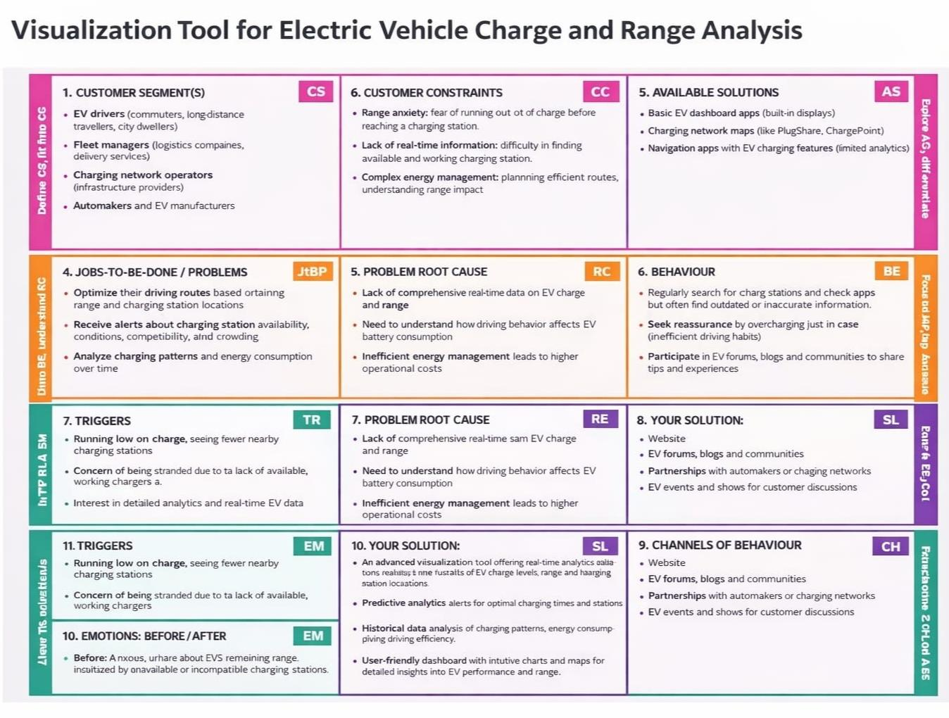

References:
https://www.ideahackers.network/problem-solution-fit-canvas/
https://medium.com/@epicantus/problem-solution-fit-canvas-aa3dd59cb4fe

